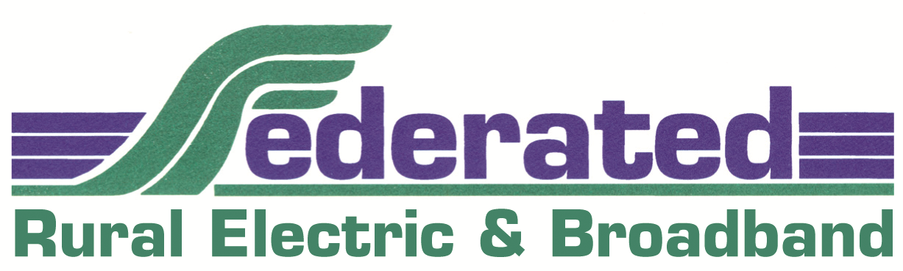
Selection procedures for
2025 Youth Tour Contest
Sponsored by Federated Rural Electric
PO Box 69, Jackson, MN 56143-0069

Contest Purpose:
Select one youth to represent Federated Rural Electric at 2025 Youth Tour, sponsored by rural electric cooperatives and held June 16-21, 2025 in Washington, D.C.

Awards: 1. First Place: Washington Youth Tour
2. Second Place: First alternate and $300
3. Third Place: Second alternate and $200
4. Fourth Place: $150
5. Up to 10 applicants $50

Eligibility:
The contest is open to any current high school freshman, sophomore, junior or senior attending school in Federated’s service area. Visit the website: www.mrea.org. Click on “Programs” then click on “Youth Tour” for photos and comments. Otherwise, visit http://youthtour.coop for photos, videos and a Youth Tour blog.

Contest:
- Contestant writes a 300-word essay (include your opinion) on an energy-related topic.

- Complete the attached application.

- Submit completed essay and application form by February 3, 2025 to:
Federated Rural Electric
ATTN: Andrea Christoffer
77100 US Highway 71
P.O. Box 69
Jackson MN 56143-0069 OR email to christoffer@federatedrea.coop

- A judging committee will select five finalists from the essays submitted.

- Five finalists will be interviewed (15 minutes per finalist) March 17, 2025, starting at 4 p.m.

- For further information on the Youth Tour Contest please contact: Andrea Christoffer at Federated Rural Electric. Work Phone: 507-847-3520 or 1-800-321-3520, extension 2224. E-mail: christoffer@federatedrea.coop.

- Previous Youth Tour winners are not eligible to enter again.

- What will you do in Washington, D.C.? Look at the next page for highlights of your Washington, D.C. trip.

(OVER)

2025 Youth Tour — 59th Year

Some of the highlights of the trip:

- 1,900 representatives from electric cooperatives all across the nation will be in D.C., including about 40 youth from Minnesota electric cooperatives. Meet with your Members of Congress in the U.S. Capitol Building and make new lifelong friends

- Tour the monuments: Washington Monument, Lincoln Memorial, Jefferson Memorial, Franklin Delano Roosevelt Memorial, Vietnam Veterans Memorial, Korean Veterans Memorial, World War II Memorial, Arlington Cemetery, Air Force Memorial, U.S. Marine Corp Monument and Martin Luther King, Jr. Memorial.

- Tour historic sites: Smithsonian Museums, Holocaust Museum, National Cathedral, 9/11 Memorial, Old Town Alexandria, Georgetown, John F. Kennedy Center and Library of Congress.

- Attend special events: Visit your Congressional leaders, boat ride on the Potomac River and evening Segway tour of the monuments on the National Mall.

- Go places: Apply to be the Minnesota representative on the Youth Leadership Council. If selected, you will travel back to D.C. in July 2026 for a youth leadership conference and also attend the National Rural Electric Cooperative Association’s Annual Meeting in Nashville, Tennessee, March 7-11, 2026.

Places and events are subject to change depending on scheduling.

n:Communications/YOUTHTOUR/applicantprocedure

