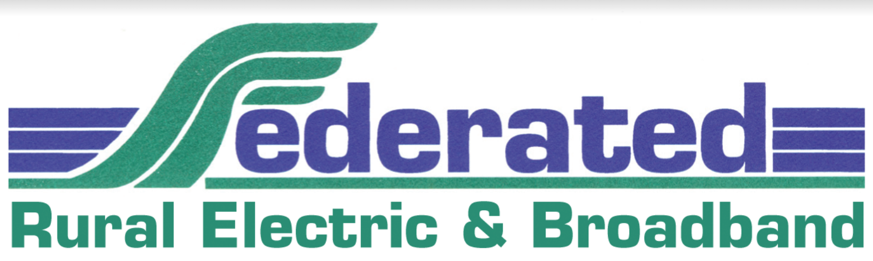

**Staff Accountant:** Federated Rural Electric Association (FREA) is a midsized electric utility and broadband service provider located in southern Minnesota in the city of Jackson. Located along Interstate 90, Jackson is nestled in a valley of the West Fork of the Des Moines River, just 20 minutes away from the beautiful Iowa Great Lakes area and within two hours of multiple major cities.

Established in 1935, Federated provides electricity to 5,300+ member-owners and 7,000 metered accounts across Jackson and Martin counties. We also provide broadband services to an ever-growing rate base of members and patrons across multiple neighboring counties, delivering reliable internet, streaming tv and VoIP phone service in southwestern Minnesota.

We are looking for an experienced and highly motivated **Staff Accountant** to maintain the integrity of the general ledger, financial reporting and payroll processing. Accurately record and interpret assigned financial and accounting transactions consistent with approved and prescribed accounting practices and procedures. You will perform month-end procedures, budgeting, auditing and some financial analyses for both the electric and broadband business units.

You will be responsible for financial reporting, payroll, journal entries, maintaining fixed assets and property records. You will prepare miscellaneous invoices, reconcile electric and broadband account receivables and coordinate the collections activity of the Cooperative.

We are looking for a continuous learner ready to collaborate with cooperative colleagues and external partners. Strong communication skills, both verbal and written, combined with an attention to detail and accuracy are important. Strong problem-solving/analytical skills and a proven ability to multi-task are critical for this role.

The successful candidate will have a Bachelors degree in accounting or finance, a minimum of 4-7 years of accounting/finance experience is required. Electric utility and NISC software *or other sophisticated financial software* experience are preferred. Experience administering benefits/retirement plans is a plus.

FREA offers a competitive pay and benefits package (expected pay range $55,000-$80,000) and the opportunity to be a part of an amazing organization and community in a beautiful area of southern Minnesota. Please send resume, cover letter, salary expectations and three professional references no later than **August 18th to Debra Englund, HRExpertiseBP** via email to [Debra@hrexpertisebp.com](mailto:Debra@hrexpertisebp.com).

**Federated Rural Electric Association is an Equal Opportunity Employer**.